Chapter 13, Solution 2.

Using Fig. 13.73, design a problem to help other students to better understand mutual inductance.

Although there are many ways to solve this problem, this is an example based on the same kind of problem asked in the third edition.

Problem

Determine the inductance of the three series-connected inductors of Fig. 13.73.

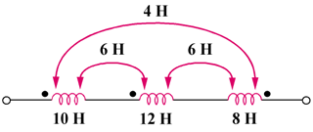

Figure 13.73

Solution

L = L₁ + L₂ + L₃ + 2M₁₂ – 2M₂₃ –2M₃₁

= 10 + 12 +8 + 2x6 – 2x6 –2x4

= 22H

